Screen Sharing
Many students benefit from being able to see anything that is projected on the board on their own device. This can be achieved through a number of programs, depending on what the school is already using.

Microsoft Teams
- Start a Teams meeting with your student.
- Open your PowerPoint/Document/Window.
- Click "Share" next to the leave button, or use the shortcut Ctrl+Shift+E.
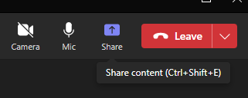
- Click "Window" and choose the one you want to share.
- If you're using a PowerPoint, start it now.
- Student can view the PowerPoint on their device, while it is also projected on the screen/whiteboard for the whole class.

Google Meet
- Start a meeting with your student in Google Meet.
- Open your PowerPoint/Document/Window.
- Click "Present now" near the hangup button.
- Click "A window" and choose the one you want to share.
- If you're using a PowerPoint, start it now.
- Students can view the PowerPoint on their device, while it is also projected on the screen/whiteboard for the whole class.
- If the student is using an iPad, they can tap and hold the presentation and choose to make it full screen.

Zoom
- Start a meeting with your student in Zoom.
- Open your PowerPoint/Document/Window.
- Click "Share Screen" or use the Alt+S shortcut.
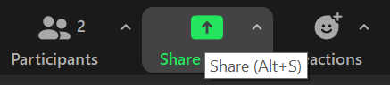
- Click on the Window you want to share (not the screen) and click "Share".
- If you're using a PowerPoint, start it now.
- Students can view the PowerPoint on their device, while it is also projected on the screen/whiteboard for the whole class.
SVRC, April 2023

