NVDA Setup Basics

Desktop
Locate the "Insert" key. If it is in an out of the way or inconvenient position, change the NVDA modifier key from "Insert" to "Caps Lock" using the instructions below.

Laptop
Change the NVDA modifier key from "Insert" to "Caps Lock" and the keyboard layout from "desktop" to "laptop".
When you open NVDA for the first time, a dialogue box will open which allows you to change the keyboard layout and the NVDA modifier key, screenshot shown below.
- Use Tab to move through the options
- Use the Up and Down Arrows to choose "laptop"
- Press Space to select the "Use CapsLock as an NVDA modifier key" checkbox
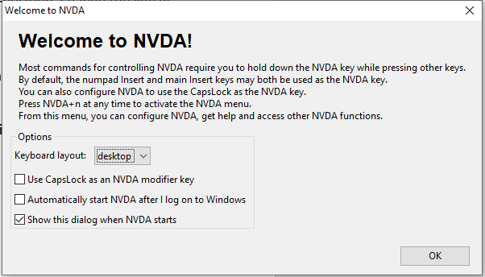
If you don't get the dialogue box when you open NVDA you can use Insert or Caps Lock + N. If Insert is not accessible do the following:
- Windows + B to get to the system tray
- Press Enter on the notification button
- Up Arrow to NVDA
- Press Enter on NVDA
- The menu should be open.
Once the menu is open:
- Down Arrow to "Preferences"
- Right Arrow to "Settings" and then press Enter. This will open the NVDA settings window
- Ctrl + Tab until you get to the "Keyboard" settings
- Tab through the settings until you hear "Keyboard layout"
- Choose laptop from the options using the Down Arrow
- Tab to the option "Select NVDA Modifier keys list"
- Use up and down arrows to find "Caps Lock" in the list, then press Space to select
- Tab to the "apply" button and press Enter.
SVRC SSP Staff (November, 2021)

