SVRC iPad Cheat Sheet

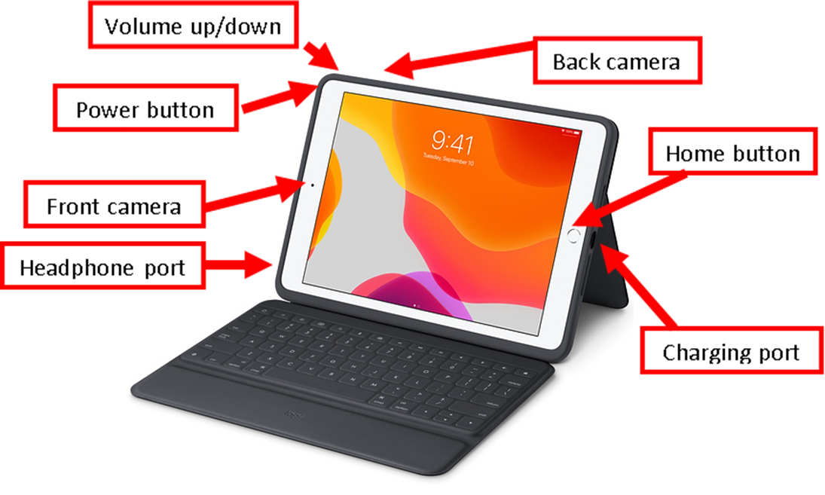
iPad (6th Gen, 9th Gen) and iPad Pro 10.5" (2nd Gen)

Physical Orientation to iPad (6th Gen) and iPad Pro 10.5" (2nd Gen)
With the iPad open and on its stand, the keyboard is closest to you. The orientation is landscape for this description.
- The home button is on the right hand side of the front of the iPad, halfway up.
- The charging port is on the side of the iPad, next to the home button.
- The Volume up/down is on the top of the iPad, on the left hand side.
- The back camera is on the back of the iPad, down from the Volume up/down button.
- The power button is on the left hand side, near the top.
- The front camera is on the front of the iPad, on the left hand side, halfway up.
- The headphone port is on the left hand side, near the bottom.

Starting the iPad
- Hold the Power button down by pressing and holding it for a few seconds. An Apple symbol will appear as the iPad starts up. If VoiceOver is enabled, the time will be read out when the iPad has turned on. Once the home screen appears, click the home button to unlock it, or enter your passcode.

Turning off the iPad
- Hold down the power button for a few seconds until 'Slide to Power off' appears. Slide to power off the iPad. If VoiceOver is on, do the same, but Double Tap when the Power off button is named.

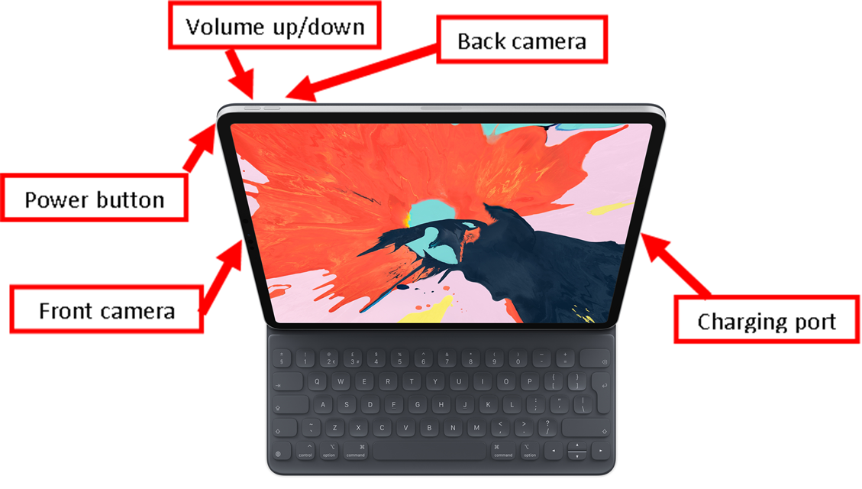
iPad Pro 12.9" (3rd Gen)

Physical Orientation to iPad Pro 12.9" (3rd Gen)
With the iPad open and on its stand, the keyboard is closest to you. These iPads don't have a home button.
- The charging port is on the right hand side of the iPad, halfway up from the bottom.
- The Volume up/down buttons are on the top of the iPad, on the left hand side. The Volume up is to the left, the Volume down is to the right.
- The back camera is on the back of the iPad, in the top left corner near the Volume up/down buttons.
- The power button is on the left hand side, near the top.
- The front camera is on the front of the iPad, on the left hand side, halfway up.
- This iPad does not have a headphone port.

Starting the iPad
- Hold the Power button down by pressing and holding it for a few (5) seconds. An Apple symbol will appear as the iPad starts up. Once the home screen appears, slide up from the bottom of the iPad to unlock it.

Turning off the iPad
- Tap the Volume up, Volume down and then hold down the Power button for a few seconds until "Slide to Power off" appears on the screen. Slide to power off.

Accessibility Options

Accessibility Shortcut
In the Accessibility menu you can put VoiceOver or Zoom as Accessibility Shortcuts. Go into "Accessibility Shortcut" and add as many shortcuts as you like. Once turned on, the Accessibility Shortcut is accessed by triple pressing the home button if there is one, or triple pressing the power button if there is no home button.
NOTE: With VoiceOver on, the iPad only responds to the VoiceOver gestures, which are different to the standard gestures. Make sure that you know how to turn off VoiceOver before turning it on! You can also use Siri to turn VoiceOver on and off.

Zoom
The iPad can enlarge the image on the screen easily using Zoom:
- Go to the Settings icon on the iPad home screen
- Select Accessibility, on the right hand side of the screen
- Tap once to select Zoom and then tap to turn it on.
Gestures - Moving the image around the screen
- Turn Zoom on or off – double tap with three fingers
- To move around screen – drag the handle at the bottom of the Zoom lens
- To go to the next screen – swipe with three fingers
For more information on Zoom check out the iPad user guide

VoiceOver
The iPad has voice output called VoiceOver. To turn it on;
- Go to the Settings Icon on the iPad home screen
- Scroll down the left hand side of the screen to "Accessibility"
- The first heading on the right hand side is VoiceOver, tap once and then tap again to turn it on
How to turn VoiceOver off
- If you have turned on the Accessibility Shortcut, triple tap the home/power button (depending on your iPad) and select VoiceOver and then double tap with one finger anywhere on the screen to turn off.
- Otherwise, go to the Settings Icon on the iPad home screen (single tap then double tap)
- Select Accessibility, find VoiceOver, and double tap to turn it off.
- Or say "Hey Siri Turn Voice Over Off"
For more information on VoiceOver check out the iPad user guide

Apps and Tips

Getting Apps on SVRC iPads
IPads loaned from SVRC are on an MDM (Mobile Device Management) system. Basic apps are available to download over Wi-Fi through the "Self Service App".
An Apple ID can also be added to the iPad through the Settings App. Choose "Sign into your iPad" just below the "Settings" title.
If any accounts are added to the iPad, sign out of them all before returning the iPad to SVRC.

Files
The Files App is one way to access the stored files on the iPad. You can also access files through specific apps.

Word Processing
Pages is the default Word Processing App on the iPad and is similar to Word on a PC. Notes is also an option for quick notes.

Books
Books is an app that can be used to open transcribed books from the SVRC. Zoom and VoiceOver will work with this app.

Camera
The Camera App allows you to take photos. A common use for low vision students is to take a photo of the classroom white board that they can then zoom in on when they're back at their desk.

Siri
Siri is a virtual assistant that you can activate using your voice. You can ask it questions, get it to set a timer, open documents etc.

Voice Memos
Record sound files.
A list of Apps available on SVRC iPads, accessing etext on the iPad and a Gesture Guide can be found on the Tech Support page of the SVRC website.
SVRC, August 2022

